16.21: Mom is five times further away than Dad, and so the intensity she hears is 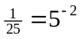of the intensity that he hears, and the difference in sound intensity levels is 